Press release
Zelebrand International

27.4.2020

Text with images. Images are delivered separately in highres under the following link.
Please use these: https://we.tl/t-uvPjejNopv

-----------------------------------------------------------------------------------------------------------------------

Zelebrand International:
Global No. 1 fintech influencer joins advisory board of Zelebrand International
((Subhead))
Brand specialists Ralf Kostgeld and Petar Dakovic have founded Zelebrand, an enterprise that combines creativity and technology for the new age. Their advisory board features the worldwide No. 1 fintech, AI and blockchain influencer. And at the same time, both Kostgeld and Dakovic sit on the advisory board of the fastest growing software agency in Europe.

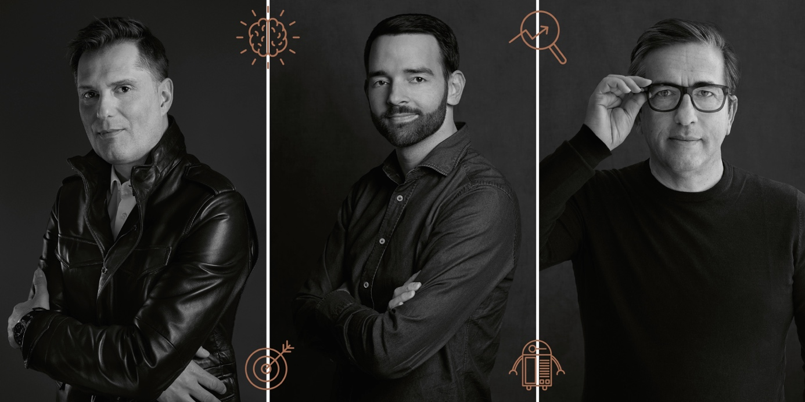
((Caption / Pic 1))
(from left) Ralf Kostgeld (Creative Partner), Petar Dakovic (Managing Partner) and Spiros Margaris (Advisory Board, Zelebrand International)

((Copy))
New times call for new constellations and solutions. Ralf Kostgeld, former global Head of Brand Creation at IWC and creative director with more than 190 international awards, and Petar Dakovic, former CEO of Detail AG and managing director of Saatchi & Saatchi Zurich, are using their experience to ensure Zelebrand International conquers tomorrow’s challenges today.

“Covid-19 has accelerated the digital transformation of most companies. The customer experience - especially digital - should now be designed and implemented as quickly and in as many places as possible while keeping relevance and individual experience in mind. This is a great opportunity to celebrate the essence of brands once again. We can help with this,” says Kostgeld.
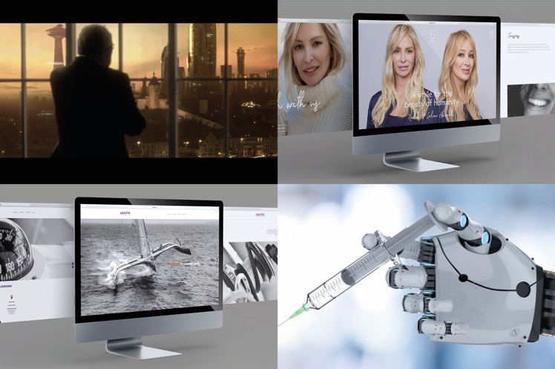
((Caption / Pic 2))
Competencies in various areas: from luxury to banking and health

Zurich-based Zelebrand has positioned itself accordingly. It places great emphasis on agility. “We want to incorporate our international expertise in such a way that every client can benefit from it,” says Dakovic. He continues, “Whether for a start-up, SME or large company, we can put together the right team for every requirement. To this end, we can also call on our external partners and specialists from Switzerland and abroad at any time, if necessary. We work leanly and effectively, ensuring that every step is right from the start and perfectly orchestrated. This means we can achieve improved ROI for our clients - with guaranteed less overhead.”

Game changer in the client portfolio

Zelebrand began its work in 2019 and has already implemented successful projects for various clients. New on the client list is London’s globally operating startup, SmartFrame. “This company is a game changer and will redefine global digital image standards and the perception of images in general, including image security. We are very excited about this cooperation,” says Kostgeld. Zelebrand is responsible for the positioning and the phased global brand rollout. SmartFrame CEO Robert Sewell explains, “It is not only the undoubtedly impressive expertise. Above all, we feel understood by Zelebrand. With farsightedness and agility, complexities are simplified and implemented with the best possible quality.” Zelebrand also acts as the official SmartFrame partner, both in Switzerland and internationally.

((Caption / Pic 3))
SmartFrame technology - enhanced presentation, image security & analytics

Unique technology expertise

Spiros Margaris, the worldwide No. 1 influencer in fintech, AI and blockchain, is on Zelebrand’s advisory board. The venture capitalist and futurist is the only person worldwide to have been awarded the "Triple Crown" by Onalytica. Ralf Kostgeld comments, “We are proud that Spiros brings his profound knowledge and insights regarding future technological developments and new business optimizations to Zelebrand International. This is an added value that we are happy to pass on to our customers.”

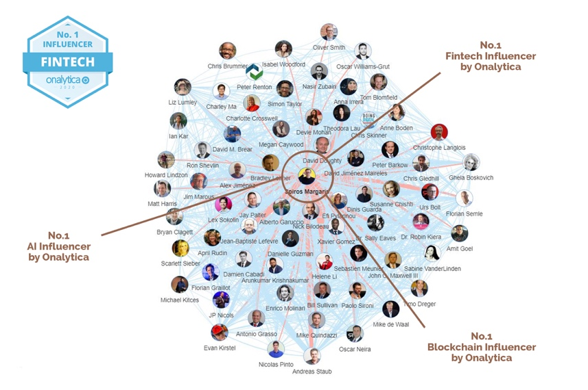

((Caption / Pic 4))
Center: Spiros Margaris, the only person worldwide to be awarded the "Triple Crown" by Onalytica

Dakovic and Kostgeld are also on the advisory board of Q Ltd, the fastest growing software agency in Europe (Deloitte Technology Fast 500 ™ in EMEA). “From UX to Web Development to Enterprise Solutions: Thanks to our unique partnership with Q, we have direct access to over 100 top developers and UX designers and are able to meet all requirements both qualitatively and economically and offer unique solutions,” Petar Dakovic says. Filip Ljubic, CEO and Founder of Q, adds, “Having Zelebrand International’s creative competence on our advisory board is of great value to Q. Not only in Switzerland, but also internationally. It’s a ‘perfect match’ from which our clients also benefit. Such synergies are in demand in today's world and can create true value.”

Creative Legal Intelligence

Another essential partner with Swiss roots is BRANDIT, one of the leading international service providers in the online brand protection and domain services sector, a subject that increases in relevance daily. Petar Dakovic explains, “Ultimately, it is about understanding the big brand impacting picture from the very beginning. The more bridges and fewer trenches, the more efficient the workflows are and the more successful our clients can be. This is why we incorporate legal into our processes right from the start.” Art Directors Club of Switzerland and Europe member Ralf Kostgeld adds, “With the CLI (Creative Legal Intelligence) methodology, we have also allowed creativity to flow into new areas. This aligns with our three pillars: creativity, technology and legal.”

((Info to pic 5: this picture is similar to picture 1, but has slightly different proportions and is intended for the small picture on the homepage. That's why the portrait-heads are a bit bigger))

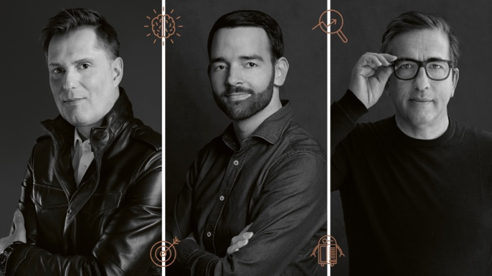

For queries and technical questions:

RALF KOSTGELD
FOUNDER / CREATIVE PARTNER
ZELEBRAND INTERNATIONAL GMBH

ADVISORY BOARD Q Ltd.
#1 Fastest Growing Software Agency in Europe
(Deloitte Technology fast 500 TM EMEA)
FORCHSTRASSE 103
8032 ZÜRICH
BRANDSTRASSE 33
8952 SCHLIEREN/ZÜRICH
SWITZERLAND
PHONE +41 79 623 32 53
SKYPE: RALFKOSTGELD
R.KOSTGELD@ZELEBRAND.COM
WWW.ZELEBRAND.COM

